Quiz 2
Part A Section
Student Id`
Question :1 Kleene’s Theorem
Find concatenation of give DFA1 and DFA2, consider q0 as initial state.
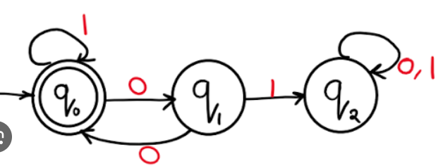 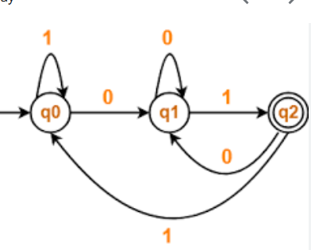S
Question :2 Minimized Given DFA.
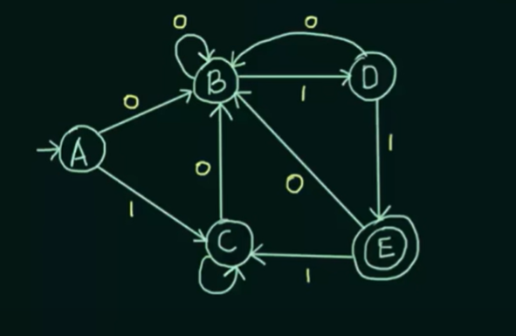

Question 3: RG,CFG
- Write a CFG which generates string having equal no of a’s and b’s.
- X(0)^{n} Y (1)^{n} Z|n>=0.
- 0^{n} 1^{m} | i!=m
- L={a² , a⁵ ,a⁸…}
- L={a^{n} b^{m} |n>=1 ,m>=1 ,nm >=3}

